VOL. 1137 PAGE 260 DEED RECORDS | DATED: August 30, 1939
#228022 | FILED: August 30, 1939
RESTRICTIONS | At 1:40 o’clock P.M.
FROM: K. E. WOMACK | TO: - - - - - - - - -
THE STATE OF TEXAS §
COUNTY OF HARRIS §

WHEREAS, K. E. Womack, of Houston, Harris County, Texas, as Owner, has subdivided and platted a tract of ground containing 35.564 acres, being a part of the Dell Tract, in the East part of lot 3 Bringhurst Subdivision, in the John Reinerman Survey, in the City of Houston, Harris County, Texas, and designated same as Crestwood, as shown by the map of said subdivision recorded in vol. 16, page 2, of the Map Records of Harris County, Texas.
NOW, THEREFORE, know all men by these presents, that K. E. Womack, for the purpose of creating and carrying out a uniform plan for the improvement and sale of property in Crestwood, as a restricted subdivision, does hereby adopt the following restrictions that shall hereafter apply to all lots and lot owners in said addition, to-wit:
- All lots in Crestwood shall be known and descripted as residential lots, except those lots which are specifically excepted in Restriction 3 below and only one single family residence and the usual accessory outbuildings used in connection with the residence shall be erected on any residential building plot.
- Lot 1 and the North 50 x 100 feet of lot 2 in block 1 may be resubdivided into two building sites facing North on Arnot Avenue, and Lot 3 and the South 50 x 100 feet of lot 2 in block 1 may be resubdivided into two building sites facing South on Byway Road, provided that the frontage of any building plot shall be not less than 80 feet.
Lots 16 and 17 in block 5 may be resubdivided into two building sites, facing South on Memorial Drive, each site to have a frontage of not less than 66 feet.
Lots 17 and 18 in block 7 may be resubdivided together into three building sites facing
South on Memorial Drive, provided that the frontage of any building plot shall be not less than 80 feet. No resubdivision of any other lot in Crestwood shall be allowed, except as specified above. However, to meet the requirements of any purchaser who may desire more frontage than is contained in the lot he selects, the subdivider may sell additional frontage from the adjoining lot, provided that no building site shall be reduced to a frontage less than that of the majority of single building sites in Crestwood, this frontage being 75 feet.
However, this restriction with respect to a minimum requirement of 75 feet shall not apply to sites as shown on the dedicated map of Crestwood, that have a frontage of less than 75 feet; these sites being lots 7 and 14 in block 2, lots 7 and 14 in block 3, lots 1 and 8 in block 4, the West ½ of lots 16 and 17 in block 5, the Ease ½ of lots 16 and 17 in block 5, lot 36 in block 5, and lot 16 in block 7.
3. Apartments, duplexes and buildings for retail business purposes with be permitted in block 1, subject to the following conditions; lot 1 and the North 50 x 100 feet of lot 2 in block 1, as resubdivided in Restriction 2 above, may be used for business. Not more than 2 business buildings and the usual accessory outbuildings and 1 gasoline filling station shall be allowed on this property, and they shall face North on Arnot Avenue, and the building line on Arnot Avenue shall be not less than 15 feet from the front property line, and the side building lines shall be at least 12 feet from and parallel with the property lines on Crestwood Drive and Haskell Street.
No noxious or offensive trade or activity shall be carried on upon any lot in Crestwood, nor shall anything be done thereon which may become an annoyance or nuisance to the neighborhood.
Apartments or duplexes may be erected n Lot 3 and the South 50 x 100 feet of lot 2 in block 1, as resubdivided in Restriction 2 above, provided no building is erected on a site having a frontage of less than 80 feet on Byway Road, and the front building line shall be not less than 25 feet from and parallel to the property line on Byway Road, and the side building lines shall be not less than 12 feet from the property lines on Crestwood Drive and Haskell Street.
All buildings erected in block 1, with the exception of accessory outbuildings, shall have exterior walls of brick, concrete, stone, stucco, of asbestos siding shingles.
No outbuilding or garage shall be erected in block 1, within 75 feet of the front property line, or within 15 of any side street property line, unless said garage is part of the main building.
- No garage, trailer basement, barn shack, tent, or other outbuilding erected in Crestwood shall at any time be used as a residence, temporarily or permanently, nor shall any structure of a temporary character be used as a residence. However, servants quarters may be constructed in connection with the garage, but shall not be occupied until after the erection of the main residence.
- No one story dwelling shall be permitted on any lot or building plot facing Memorial Drive that has a ground floor square foot area of less than 1,200 square feet, or a frontage of less than 30 lineal feet; and no one and one-half or two story dwelling shall be permitted that has a
ground floor square foot area of less than 800 square feet, or a frontage of less than 25 lineal feet.
On all other lots and building plots in Crestwood, no one story dwelling shall be permitted that has a ground floor square foot area of less than 1,000 square feet, or a frontage of less than 25 lineal feet; and no one and one-half or two story dwelling shall be permitted that has a ground floor square foot area of less than 700 square feet, or a frontage of less than 25 lineal feet.
All frame buildings shall receive at least two coats of paint at the time of construction.
Concrete sidewalk 4 feet in width, located 2 feet from front property line, and in accordance with City of Houston Engineering Department specifications, shall be constructed at the builder’s expense across the front of the lot as each dwelling is erected.
In other words, this sidewalk shall be constructed at the same time that the builder constructs the driveway and any other sidewalk that the owner may require in connection with the construction of the home.
No building shall be erected, altered, placed or permitted to remain on any building lot in Crestwood until the external design and location thereof have been approved in writing by the Committee which shall be appointed or elected by the owner or owners of a majority of the lots which are subject to the covenants herein set forth. However, if the Committee fails to approve or disapprove such design or location within 30 days after such plans have been submitted to it, then such approval will not be required. The completion of construction, alteration, or placement of a structure for thirty days shall be construed as prima-facie evidence of committee approval.
- All improvements shall be constructed on the lot or building plot so as to front the street upon which such lot or building plot faces, with the following exceptions: Garages on corner lots may face side streets, subject to building line requirements as set out in Restriction 7 below. In block 1, as resubdivided in Restriction 2 above, the main building shall face North on Arnot Avenue and South on Byway Road.
On Lots 16 and 17 in block 5, as resubdivided in Restriction 2 above, the main buildings shall face South on Memorial Drive. On account of the following lots having frontage on two streets, the specific direction in which improvements shall face is herein set out;
Lot 36 in block 5 shall front on Memorial Drive. Lot 14 in block 6 shall front in a Westerly direction on West Cowan Drive. Lot 28 in block 6 shall front in an Easterly direction on East Cowan Drive. Lot 16 in block 7 shall front in a Northwesterly direction on Cowan Drive.
- On all lots in blocks 2 and 3, lots 1 to 15 inclusive, and lots 18 to 32, inclusive, in block 5, lots 1 to 13, inclusive, and lots 15 to 27 inclusive, in block 6, the front building line shall be not less than 25 feet from and parallel to the front property line.
On all lots in block 4, and lots 1 to 12 inclusive, in block 7, the front building line shall be not less than 20 feet from and parallel with the front property line. On lots 33 to 36, inclusive, in block 5, and lots 17 and 18 in block 7, facing Memorial Drive, the front building line shall be not less than 30 feet from and parallel with the front property line.
On lots 16 and 17 in block 5, as resubdivided in Restriction 2 above, facing Memorial Drive, the building line shall be not less than 30 feet from and parallel with the front property line.
On triangular lot 14 in block 6, the West building line shall be a continuation of the building line for lots 1 to 13, when produced South, and the South building line shall be not less than 8 feet from the South property line. On Triangular lot 28 in block 6, the East building line shall be a continuation of the building line for lots 15 to 27 when produced South, and the South building line shall be not less than 8 feet from the South property line.
On lot 16 in block 7, both the Northerly and Westerly building lines shall be at least 15 feet from the property line, and the South building line shall be not less than 30 feet from the property line. On lots 13-15 inclusive, in block 7, the building line shall be not less than 15 feet from the parallel with the front property line. On corner lots 7 and 14, in block 2, lots 7 and 14 in block 3 and lot 8 in block 4, the main building shall be not than 8 feet from the side street property line.
On all other corners in Crestwood except when otherwise specified in these restrictions, the main building shall be not less than 10 feet from the side street property line.
Not outbuilding or garage shall be erected on any lot or building plot within 75 feet of the front property line, or within 15 feet of any side street property line, unless said garage is part of the residence.
- There shall be a permanent easement 10 feet in width on the rear of each lot in Blocks 4 and 7, and 5 feet in width on the rear of all other lots, or as is provided in the dedicated plat of Crestwood, for the construction and maintenance of sewer, gas, telephone, and electric light services. There shall also be an easement of 5 feet in width along the South line of lot 1 in block 4 for a connecting gas main, as well as other utilities.
- Property in Crestwood shall never be sold, leased, or rented to any person other than of the Caucasian Race.
- If the parties hereto, or any of them, or their heirs or assigns, shall violate or attempt to violate any of the covenants or restrictions herein, it shall be lawful for any other person or persons owning any other lots in Crestwood to prosecute any proceeding at law or in equity against the person or persons violating or attempting to violate any such covenant or restriction, either to prevent him or them from so doing, or to recover damages or other due for such violation.
- All of the restrictions, covenants, and reservations herein, as well as any appearing in contract, deed, or other conveyance, to any part of the property, shall be construed together, but if any one of them shall be held to be invalid or for any reason is not enforced, none of the others shall be affected or impaired thereby, but shall remain in full force and effect.
- All of the restrictions and covenants herein set forth shall continue for a period of twentyfive (25) years from the date this instrument is filed for record in the office of the County Clerk of Harris County, Texas, and shall automatically be extended thereafter for successive periods of the years; provided, however, that should the owners of a majority of the lots in Crestwood desire to change, modify, or eliminate the said restrictions, they may do so by executing and acknowledging an appropriate agreement in writing for such purpose, and filing the same for record in the manner then required for the recording of land instruments, at least one (1) year prior to the expiration date of the first 25 year period, and at least one (1) year prior to the expiration of any 10 year period thereafter.
Witness by hand at Houston, Texas, this 30 day of August, A. D. 1939.

K. E. Womack.
_______________________
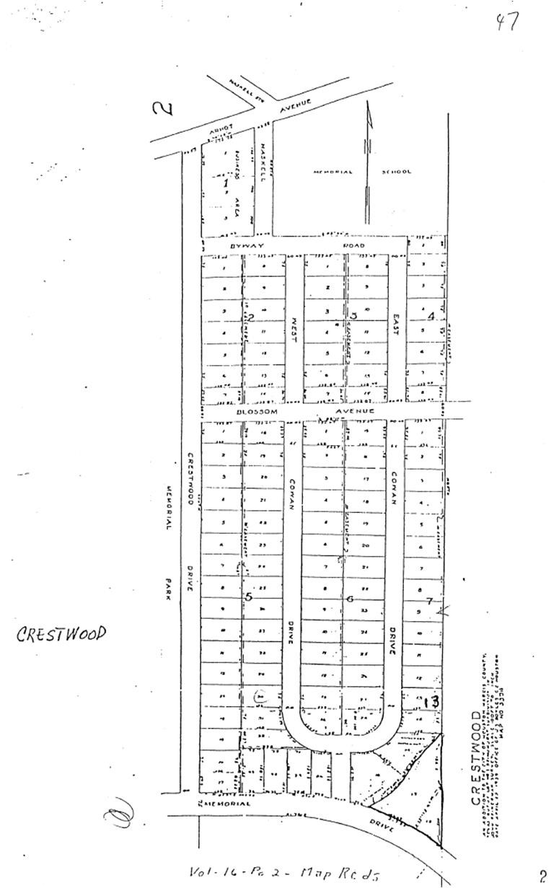
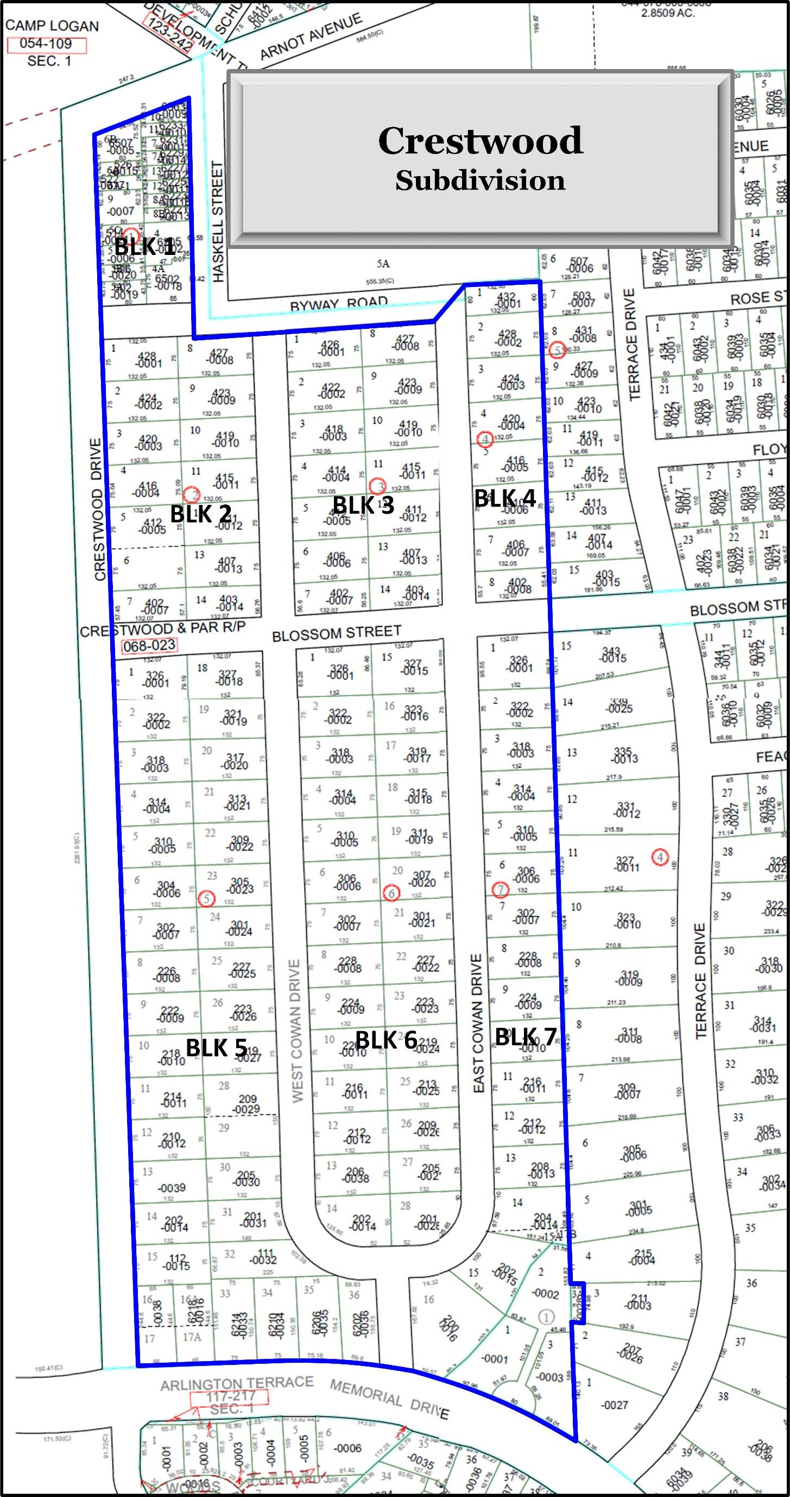

AMENDMENT TO RESTRICTIONS
APPLICABLE TO CRESTWOOD SUBDIVISION

THE STATE OF TEXAS §
§
COUNTY OF HARRIS §

WHEREAS, on August 30, 1939, K. E. Womack filed of record Restrictions applicable to Crestwood Subdivision, as shown by the map of said subdivision recorded in Volume 16, Page 2 of the Map Records of Harris County, Texas, which restrictions are recorded in Volume
1137 at Page 260 of Deed Records of Harris County, Texas (hereinafter referred to as the
“Original Restrictions”); and
WHEREAS, during 1945, John D. Townsend, Jr. gave deeds to each lot on Block 1 of Crestwood in which certain additional restrictions were made applicable to Block 1 (hereinafter referred to as the “Additional Restrictions”); and
WHEREAS, during December of 1981, the owners of all lots in Block 1 executed in waiver of the “Additional Restrictions”, which document is filed under Film Code Reference 003-81-1848 in the Real Property Records of Harris County, Texas; and
WHEREAS, a document entitled Amendment to Reservations, Covenants and
Restrictions Applicable to Crestwood Subdivision was executed by various individuals claiming to be owners of lots in Crestwood, which document was filed for record on three separate occasions during January and February of 1982 (hereinafter referred to as the “First
Amendment”); and
WHEREAS, during February of 1982, certain individuals who had executed the First Amendment signed documents entitled Retraction of Amendment to Reservations, Covenants and Restrictions Applicable to Crestwood, which retractions were filed in the Real Property
Records of Harris County, Texas,during February of 1982; and
WHEREAS, the undersigned, each of whom owns an interest in a lot in Crestwood, desire by this Agreement executed in multiple counterparts to amend the restrictions applicable to Crestwood Subdivision, and in particular to Block 1 thereof;
NOW, KNOW ALL MEN BY THESE PRESENTS THAT:
The undersigned, each of whom represents by his or her signature on a counterpart of this Agreement, that he or she is an owner of a lot or an interest in a lot in Crestwood Subdivision, does hereby agree for and in consideration of the mutual benefits derived hereby, including the clarification of the Original Restrictions and the establishment of new Restrictions in keeping with the general scheme of Restrictions in effect in Crestwood, with each other signatory of an identical counterpart to this Agreement, that the Original Restrictions, as amended by the Additional Restrictions, and whether or not the First Amendment is valid or later becomes valid, are amended as follows:
The first sentence of Restriction 2 of the Original Restrictions is deleted, and is replaced in full by the following:
Lot 1 and the north half of Lot 2 in Block 1 may be resubdivided into two (2) building sites, and Lot 3 and the south half of Lot 2 in Block 1 may be resubdivided into two (2) building sites, provided that the width of any such building site measured east to west shall not be less than eighty feet (80’). Each resultant building site shall be referred to herein as a quandrant of Block 1.
Restriction 3 of the Original Restrictions is deleted in its entirety, and the following restriction is adopted in its place:
3. No commercial or business use of Block 1 shall be permitted. Duplexes, townhouses or condominiums, including more than one single dwelling unit, shall be permitted on Block 1 if, and only if, the plans and construction thereof comply with each of the following restrictions:
- The front and side building lines on all of Block 1 shall be twelve feet (12’) from and parallel with the property lines on Arnot Avenue, Haskell Street, Byway Road and Crestwood Drive.
- No building of any type may be erected on Block 1 that is greater than thirty feet (30’) in height or two (2) stories in height, whichever is the lesser.
- All buildings erected on Block 1 shall have exterior walls of wood, brick, concrete, stone or stucco.
- No single dwelling unit may be occupied by more than one (1) single family.
- No construction that would result in more than one (1) single dwelling unit on each quadrant of Block 1 may be commenced until the plans are first submitted to the Crestwood Architecture Committee (hereinafter referred to as the “Committee”), which shall approve said plans if, and only if:
  - Each single dwelling unit complies with all restrictions applicable to the remainder of Crestwood, including specifically the minimum square footage and lineal frontage requirements.
  - Rules and regulations applicable to the units so constructed must be submitted with the plans, which rules must be made specifically enforceable by and owner of a lot in Crestwood, and must regulate the use of such multiple dwelling unit project so that the higher density thereof will not unduly interfere with the use and enjoyment of lots in Crestwood by the owners thereof.
  - The external design and location on each quadrant of Block 1 must be acceptable to the Committee.
No noxious or offensive trade or activity shall be carried on upon any lot in Crestwood, nor shall anything be done thereon which may become an annoyance or nuisance to the neighborhood.
The following portion of Restriction 5 of the Original Restrictions is eliminated in its entirety:
“No building shall be erected, altered, placed or permitted to remain on any building lot in Crestwood until the external design and location thereof have been approved in writing by the Committee which shall be appointed or elected by the owner or owners of a majority of the lots which are subject to the covenants herein set forth. However, if the Committee fails to approve or disapprove such design or location within 30 days after such plans have been submitted to it, then such approval will not be required. The completion of construction, alteration, or placement of a structure for thirty days shall be construed as prima-facie evidence of committee approval.”
and shall be replaced in its entirety by the following:
No building or other structure shall be erected, altered, remodeled, placed or permitted to remain on any building lot until the external design, location and conformity to these restrictions have been approved in writing by the Committee. The Committee shall be composed of William C. Owens, J. James Raymond, Jr., Robert Robertson, Albert E. Sheppard and Ben H. Bradley. If any member of the Committee moves from Crestwood or otherwise becomes unwilling or unable to serve, a replacement for such member shall be selected by a majority of the remaining members of the Committee. Any member of the Committee may be removed by the affirmative vote of two-thirds
(2/3) of the remaining members of the Committee. Any or all of the members of the Committee may be removed or placed by the affirmative vote in writing of the owners of sixty-two (62) lots in Crestwood. No person may serve on the Committee unless such person owns an interest in a lot in Crestwood.
Should the Committee disapprove any plans, notice of such disapproval shall be given within five (5) days to the owners of lots in Crestwood. If the Committee fails to approve or disapprove any plans submitted to it within thirty (30) days of the date of submittal, such approval by the Committee will be deemed to have been given; provided, however, that failure of the Committee to approve or disapprove plans submitted to it shall not constitute a defense to an action brought by any owner of a lot in Crestwood to enforce these restrictions.
All actions by the Committee shall be valid only by a written vote of at least twothirds (2/3) of all members of the Committee. Such written vote records shall be kept by the Committee, and such records shall be made available to any lot owner in Crestwood upon written request of such lot owner.
The following sentence of Restriction 6 of the Original Restrictions shall be eliminated:
“In block 1, as resubdivided in Restriction 2 above, the main building shall face
North on Arnot Avenue and South on Byway Road.”
Restriction 12 of the Original Restrictions is deleted in its entirety, and replaced with the following:
All of the restrictions and covenants herein set forth shall continue for a period of twenty-five (25) years from August 30, 1939, the date the Original Restrictions were filed for record in the office of the County Clerk of Harris County, Texas, and shall automatically be extended thereafter for successive periods of ten (10) years; provided, however, that the restrictions may be altered, modified, amended or eliminated if, and only if, the following procedures are followed:
- The alteration, modification, amendment or elimination document (hereinafter referred to as the “Amendment Agreement”) must be executed and acknowledged by each person signing same on or after July 1 and on or before August 30 of the last year of each automatic 10-year extension or, in other words, each year ending in the number four (4) (hereinafter referred to as
“Amendment Year”);
- Each signature of an owner must be acknowledged and must appear on an identical counterpart of the Amendment Agreement;
- No executed counterparts of the Amendment Agreement may be filed for record until counterparts have been executed by all of the owners of at least eight (80) lots in Crestwood; and
- All counter parts of the Amendment Agreement must be recorded at one time in the Harris County Real Property Record and prior to August 30 of any Amendment Year, but no earlier than July 1 of any Amendment Year.
- Any Amendment Agreement executed and recorded in accordance with a) – d) above shall be effective on September 1 of the Amendment Year.
Notwithstanding the foregoing, the restrictions applicable to Crestwood may be eliminated at any time upon the execution and acknowledgment of an appropriate instrument in multiple counterparts by all of the owners of at least one hundred and ten (110) lots in Crestwood.
Any person in whose name a lot appears according to a deed recorded in the Real Property Records of Harris County shall be presumed to be the owner of such lot for purposes of determining the number of owners of lots executing the Amendment Agreement. Notice of the filing of the Amendment Agreement must be given by hand delivery to each lot in Crestwood of a copy of such Agreement.
In any vote concerning the alteration, modification, amendment or elimination of the restrictions in Crestwood, each quadrant of Block 1 shall be entitled to one (1) vote only, notwithstanding the number of dwelling units on such quadrant, and Block 1 shall be entitled in total to no more than four (4) votes on any such instrument.
By his or her signature hereon, each of the undersigned does hereby ratify and confirm the Original Restrictions, as amended by this instrument only, whether or not the undersigned may have executed the First Amendment, and each of the undersigned does expressly confirm that except as amended herein, no part of parts of the Original Restrictions have been waived, modified or amended, but do remain in full force and effect.
If any provision of this Agreement shall be held to be invalid, or for any reason any provision is not enforced, none of the others shall be affected or impaired thereby, but shall remain in full force and effect.
The undersigned hereby represents that he or she is an owner of or the owner of an interest in Lot _____, Block ______ of Crestwood Subdivision.

THIS AGREEMENT is executed in multiple counterparts effective the date of the acknowledgment hereof.

x_____________________________________________
Signature of Lot Owner
Printed or Typed Name: __________________________
Address of Lot Owner: ___________________________
______________________________________________

THE STATE OF TEXAS §
§
COUNTY OF HARRIS §

This instrument was acknowledged before me on _____________________________ by __________________________________________________ .

____________________________________
Printed or Typed Name: ________________
Notary Public, State of Texas
My commission expires: _______________

